**Autonomous Reforestation Robot: ML Model for Crop Recommendation**

**PDE4433 – Machine Learning for Robotics**

**Coursework 01**

N. G. Jayashanka Anushan

MISIS – M01037028

MSc in Robotics

Middlesex University Dubai

# Table of Contents

Table of Contents 2

1). Introduction 3

2). Used Dataset 3

3). Analysis 5

3.1). Machine Learning for Robotics 5

3.2). Methodology 6

3.3). Used ML model and effectiveness 6

3.3.1). Soil Type Prediction Model 6

3.3.2). Crop Type Prediction Model 9

3.4). Model Evaluation 12

4). Conclusion 13

5). Future improvements. 13

6). Live Demonstration 14

7). References 14

***List of figures***

Figure 2‑1 Image Dataset Sample Source:(Author Developed) 4

Figure 2‑2 Tabular dataset Sample Source:(Author Developed) 5

Figure 2‑3 Data flow chat of the system source:(Author Developed) 5

Figure 3‑1 Model developed with CNN architecture Source:(Author Developed) 6

Figure 3‑2 Training cycle testing training and test accuracy Source:(Author Developed) 7

Figure 3‑3 Soil prediction testing code Source:(Author Developed) 7

Figure 3‑4 Scenario 01 test results Source:(Author Developed) 8

Figure 3‑5 Scenario 02 test results Source:(Author Developed) 8

Figure 3‑6 Scenario 03 test results Source:(Author Developed) 9

Figure 3‑7 Features of the dataset Source:(Author Developed) 9

Figure 3‑8 Numerical Data distribution Source:(Author Developed) 10

Figure 3‑9 Features separation Source:(Author Developed) 10

Figure 3‑10 Split dataset Source:(Author Developed) 10

Figure 3‑11 Decision Tree model training cycle summary Source:(Author Developed) 11

Figure 3‑12 Random Forest model training cycle summary Source:(Author Developed) 11

Figure 3‑13 Final system prediction Source: (Author Developed) 12

***List of tables***

Table 1 Dataset Size source: (Author developed) 3

Table 2 Image Dataset Description source: (Author developed) 4

Table 3 Tabular Dataset Description source: (Author developed) 4

# ****Introduction****

This project focuses on developing an Autonomous Reforestation Robot powered by machine learning. The system is designed to comprehensively scan designated areas and collect critical environmental parameters—including soil texture, moisture, humidity, and nutrient levels (nitrogen, potassium, and phosphorus)—through integrated sensors. These data are analyzed to determine the most suitable crop type for reforestation or agricultural purposes.

The machine learning pipeline employs supervised learning to process sensor inputs, correlate them with agronomic requirements, and generate optimized crop recommendations. By systematically evaluating environmental conditions and aggregating multisource data, the model ensures precise, data-driven decisions. This approach aims to enhance reforestation accuracy and promote sustainable land management through autonomous, intelligent systems.

An additional robotic application, such as an automated seed-planting mechanism or drone-assisted terrain mapping, can significantly boost the efficiency of this project by enabling precise seed placement and expanded environmental coverage, further supporting large-scale agricultural and forestation initiatives.

# Used Dataset

For the analysis propose the data collected from Kaggl.com. Below is the data sources that collected data for analysis.

1. Image datasets;

* <https://www.kaggle.com/datasets/prasanshasatpathy/soil-types>
* <https://www.kaggle.com/datasets/jhislainematchouath/soil-types-dataset>

1. Tabular datasets;

* <https://www.kaggle.com/datasets/varshitanalluri/crop-recommendation-dataset>

As per the concept of the proposed development, two models are involved in the system, with each model interacting with the other. The first model is designed to process and predict based on image data, while the second model operates solely on tabular data. To align with the requirements of the second dataset, the image dataset had to be manually preprocessed before it could be utilized for training the image prediction model. The tabular dataset includes five distinct soil types: *'Black', 'Clayey', 'Loamy', 'Red',* and *'Sandy'*. Accordingly, using the two datasets obtained from Kaggle, a customized dataset was created to train the first model. The image data was categorized into training, validation, and testing sets to facilitate effective model development and evaluation.

Table Dataset Size source: (Author developed)

|  |  |  |
| --- | --- | --- |
|  | Image dataset | Tabular dataset |
| Size | * 83 images total for training * 20 images total for validation | (Rows: 2200, Columns: 9) |
| Columns / Classes | *'Black', 'Clayey', 'Loamy', 'Red',* *'Sandy'* | 'Nitrogen', 'Phosphorus', 'Potassium', 'Temperature', 'Humidity', 'pH_Value', 'Rainfall', 'Crop', 'SoilType' |

Table Image Dataset Description source: (Author developed)

|  |  |  |  |  |  |  |  |  |
| --- | --- | --- | --- | --- | --- | --- | --- | --- |
| **width** | | | | | | | | |
| **class** | **count** | **mean** | **std** | **min** | **25%** | **50%** | **75%** | **max** |
| **Black** | 17 | 297.470588 | 112.154535 | 225 | 265 | 275 | 275 | 728 |
| **Clayey** | 17 | 311 | 0 | 311 | 311 | 311 | 311 | 311 |
| **Loamy** | 17 | 504.823529 | 501.713219 | 199 | 259 | 315 | 474 | 1937 |
| **Red** | 17 | 512.529412 | 566.236823 | 193 | 259 | 275 | 640 | 2496 |
| **Sandy** | 15 | 441.066667 | 62.000538 | 300 | 450.5 | 474 | 474 | 475 |
| **height** | | | | | | | | |
| **class** | **count** | **mean** | **std** | **min** | **25%** | **50%** | **75%** | **max** |
| **Black** | 17 | 218.647059 | 131.820399 | 162 | 183 | 183 | 190 | 728 |
| **Clayey** | 17 | 162 | 0 | 162 | 162 | 162 | 162 | 162 |
| **Loamy** | 17 | 481.235294 | 507.281176 | 200 | 258 | 301 | 360 | 1936 |
| **Red** | 17 | 363.411765 | 388.285182 | 57 | 183 | 183 | 480 | 1664 |
| **Sandy** | 15 | 416.8 | 101.853677 | 270 | 314.5 | 474 | 474 | 631 |

Table Tabular Dataset Description source: (Author developed)

|  |  |  |  |  |  |  |  |
| --- | --- | --- | --- | --- | --- | --- | --- |
|  | **Nitrogen** | **Phosphorus** | **Potassium** | **Temperature** | **Humidity** | **pH_Value** | **Rainfall** |
| **count** | 2200 | 2200 | 2200 | 2200 | 2200 | 2200 | 2200 |
| **mean** | 50.551818 | 53.362727 | 48.149091 | 25.616244 | 71.481779 | 6.46948 | 103.463655 |
| **std** | 36.917334 | 32.985883 | 50.647931 | 5.063749 | 22.263812 | 0.773938 | 54.958389 |
| **min** | 0 | 5 | 5 | 8.825675 | 14.25804 | 3.504752 | 20.211267 |
| **0.25** | 21 | 28 | 20 | 22.769375 | 60.261953 | 5.971693 | 64.551686 |
| **0.5** | 37 | 51 | 32 | 25.598693 | 80.473146 | 6.425045 | 94.867624 |
| **0.75** | 84.25 | 68 | 49 | 28.561654 | 89.948771 | 6.923643 | 124.267508 |
| **max** | 140 | 145 | 205 | 43.675493 | 99.981876 | 9.935091 | 298.560117 |

**Final dataset sample view**

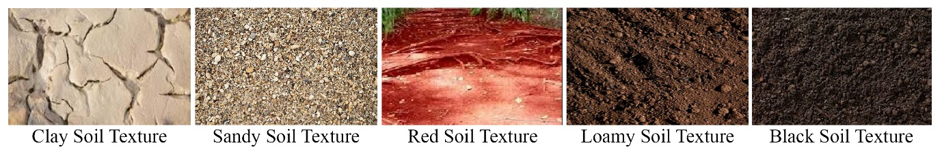

Figure ‑ Image Dataset Sample Source:(Author Developed)

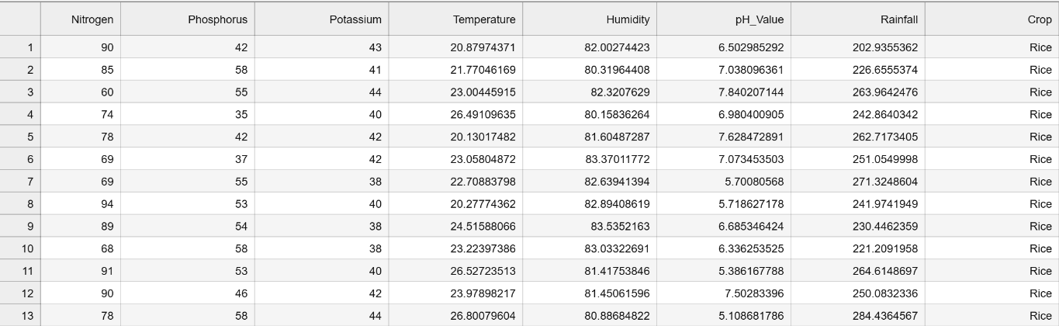

Figure ‑ Tabular dataset Sample Source:(Author Developed)

**Data flow of the system via prediction models**

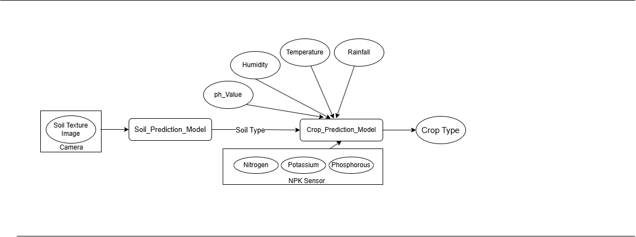

Figure ‑ Data flow chat of the system source:(Author Developed)

# Analysis

## Machine Learning for Robotics

Main task of this project is to create a suitable machine learning model. Collecting real-time environmental data and processing the data to generate accurate predictions.

The collected data is analyzed to predict the most suitable crop type for the given area. To achieve this, a trained machine learning model is employed, capable of making accurate predictions based on the acquired data. Machine learning techniques are used to enhance the model's predictive capabilities, ensuring reliable and data-driven decision-making for the project.

By integrating machine learning into robotics, this project aims to develop an intelligent system that can autonomously collect, process, and analyze environmental data, contributing to more efficient and precise agricultural planning.

## Methodology

This project employs a multimodal data approach, utilizing both image-based and tabular datasets to achieve its objectives. The methodology integrates heterogeneous data sources, including visual (image), textual, and numerical data, each processed through specialized machine learning pipelines. Image data undergoes computer vision-based analysis, while textual and numerical data are processed through structured machine learning models. This dual-stream architecture ensures comprehensive feature extraction and enables robust predictive performance by leveraging the complementary strengths of different data modalities.

## Used ML model and effectiveness

Since the final target outcome is categorical data, decided to train model with Decision Tree and Random Forest architectures.

### Soil Type Prediction Model

The model utilizes camera-captured images as input, processed through a Convolutional Neural Network (CNN) architecture. The implemented CNN sequentially processes standardized 224×224-pixel images through 17 layers to predict soil types following architecture:

1. Input layer accepting standardized 224×224-pixel RGB images
2. Four convolutional blocks, each containing:
   1. Conv2D layer with ReLU activation
   2. BatchNormalization layer
   3. MaxPooling2D layer for spatial down sampling
3. Flatten layer for feature vector conversion
4. Fully-connected Dense layer (256 units, ReLU activation)
5. Dropout layer (rate=0.5) for regularization
6. Output Dense layer with softmax activation for multi-class classification

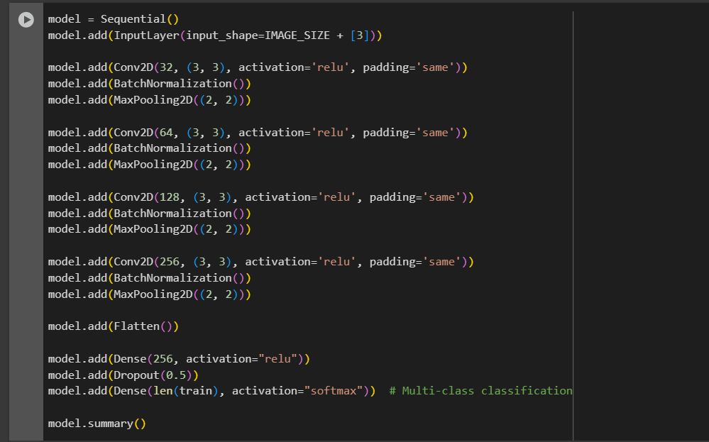

Figure ‑ Model developed with CNN architecture Source:(Author Developed)

The architecture employs Batch Normalization after each convolutional layer to accelerate training convergence and improve gradient flow. The strategic combination of MaxPooling layers and a final Dropout layer (p=0.5) prevents overfitting while maintaining spatial feature hierarchies. This deep network structure enables robust feature extraction from soil texture images, with the 256-unit Dense layer serving as a high-dimensional feature space for final classification decisions.

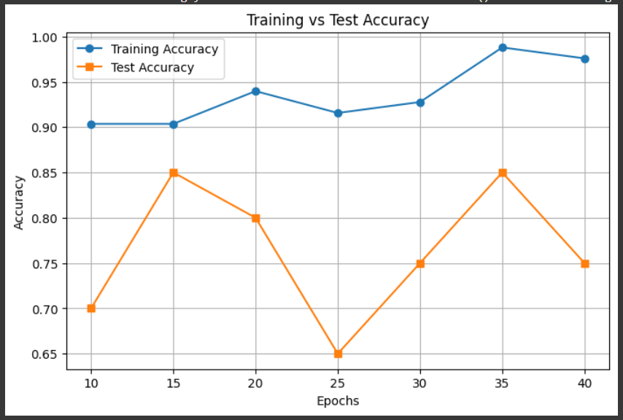

Figure ‑ Training cycle testing training and test accuracy Source:(Author Developed)

Based on the distribution analysis, a 15-cycle training model was selected to ensure optimal performance. The selection was made considering the following factors:

1. **Avoidance of Overfitting**: The model maintained a balanced learning curve, preventing excessive variance between training and validation data.
2. **Prediction Accuracy**: The model's predictions were evaluated against the dataset, demonstrating satisfactory results without significant deviation.
3. **Performance Stability**: The training process showed consistent improvement across cycles without unnecessary complexity, making 15 cycles an ideal choice.

This approach ensures that the model generalizes well to unseen data while maintaining reliable predictive accuracy.

**Testing Image model prediction;**

Scenario 01: Expected result is Red.

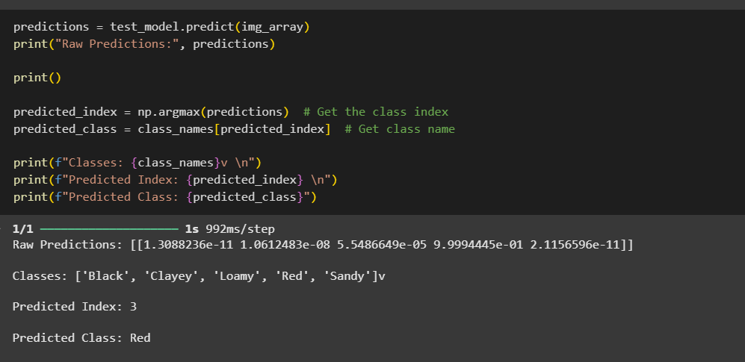

Figure ‑ Soil prediction testing code Source:(Author Developed)

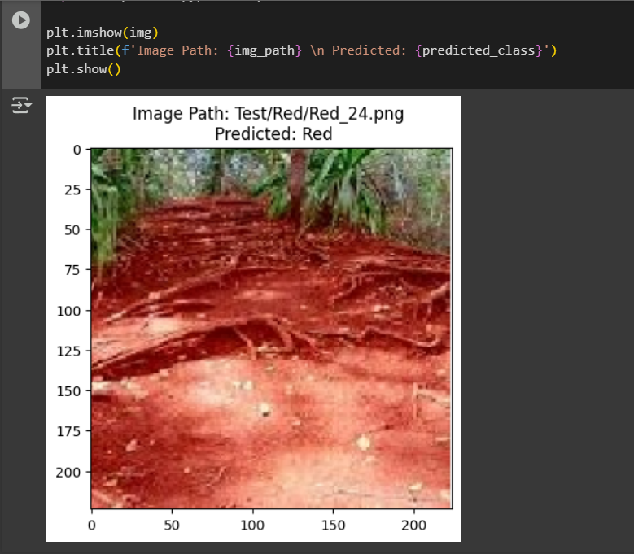

Figure ‑ Scenario 01 test results Source:(Author Developed)

Scenario 02: Expected result is Sandy

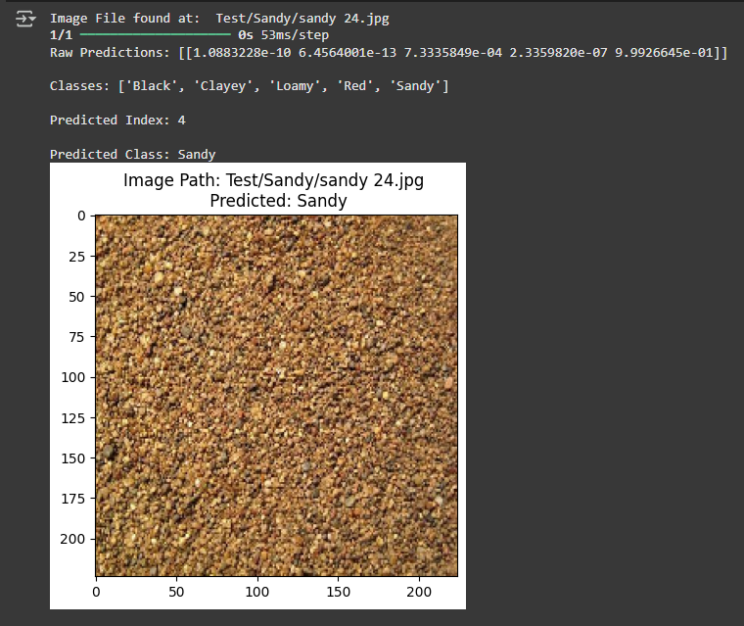

Figure ‑ Scenario 02 test results Source:(Author Developed)

Scenario 03: Expected result is Loamy

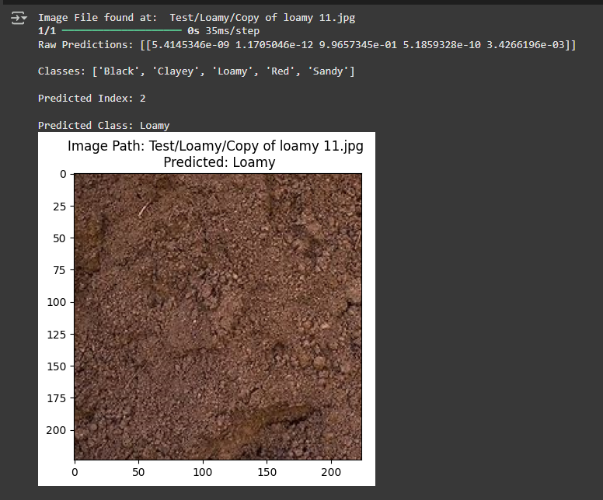

Figure ‑ Scenario 03 test results Source:(Author Developed)

### Crop Type Prediction Model

The second model is responsible for predicting the most suitable crop type based on the analyzed data. To achieve optimal performance, multiple machine learning algorithms will be tested, and the best-performing model will be selected for the final implementation. The models considered for this phase include:

1. Decision Tree
2. Random Forest

By evaluating these models, the most accurate and efficient algorithm will be integrated into the project to enhance prediction reliability.

Selected dataset has several fields as below;

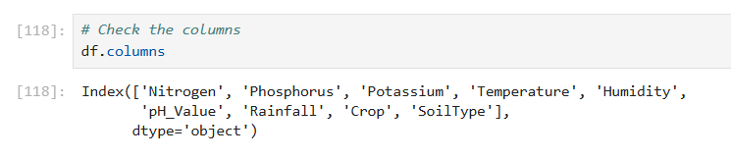

Figure ‑ Features of the dataset Source:(Author Developed)

Data scattering in tabular dataset (numerical data);

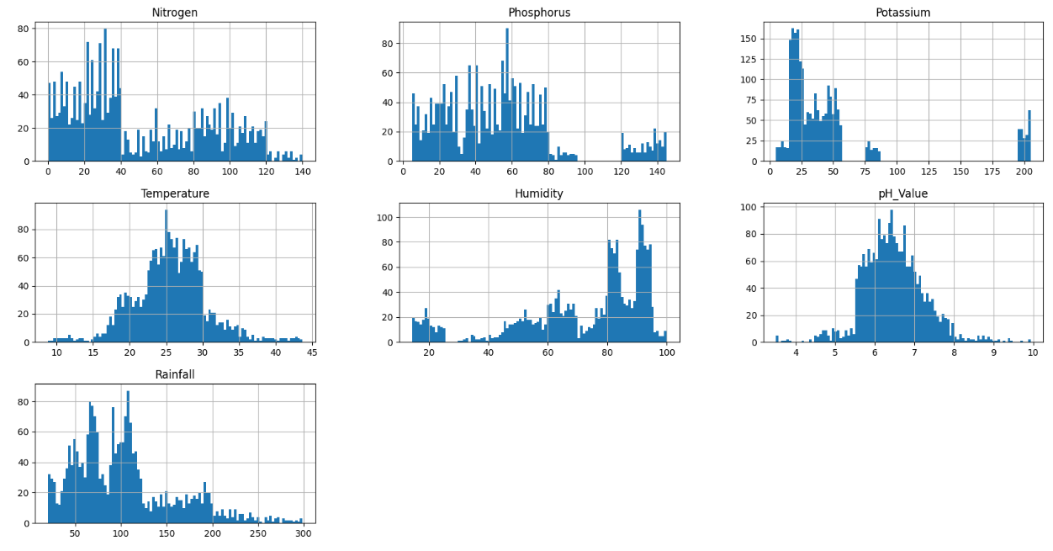

Figure ‑ Numerical Data distribution Source:(Author Developed)

Features separated for model training as ‘x1_feature’ and ‘y1_feature’;  
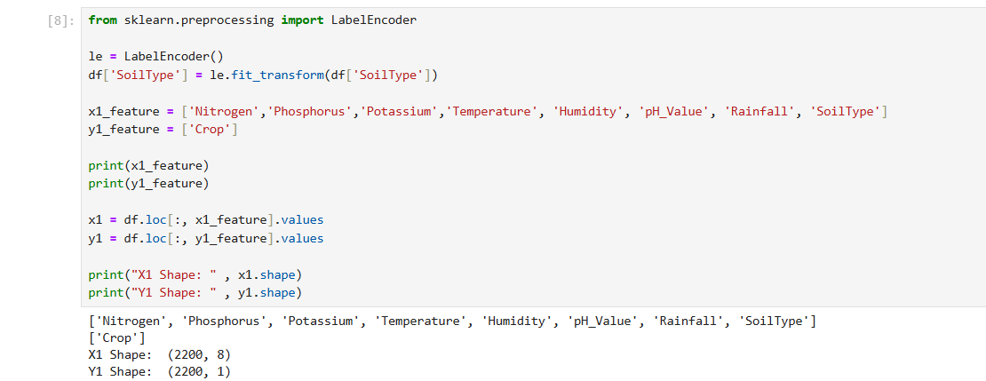

Figure ‑ Features separation Source:(Author Developed)

Split dataset into 70% for training and 30% for testing.

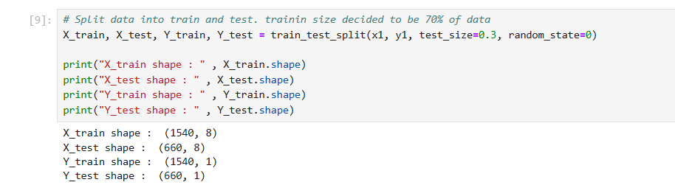

Figure ‑ Split dataset Source:(Author Developed)

**Testing with Decision Tree Model**

The model, trained using a Decision Tree architecture, was tested across a range of depths to determine the optimal training cycles.

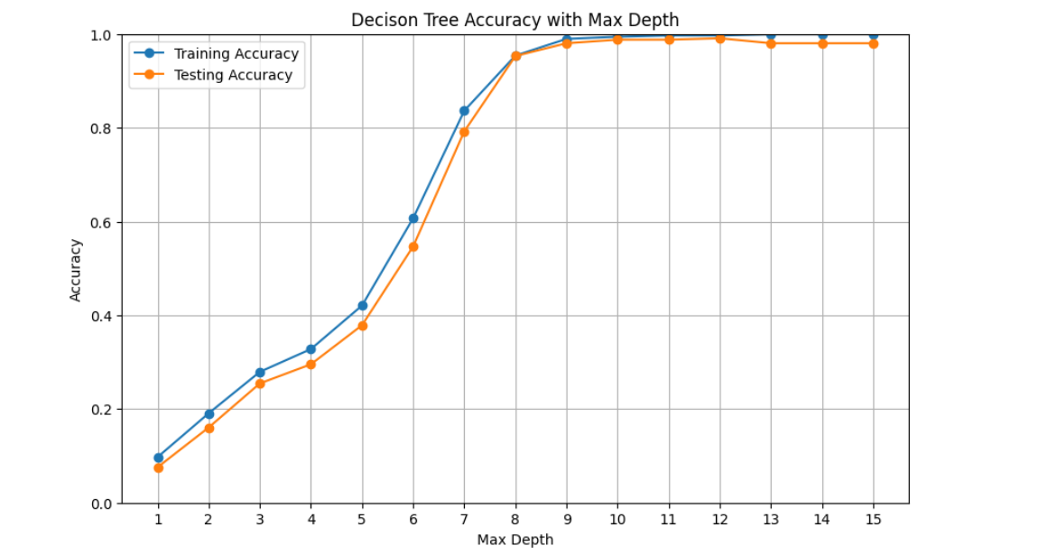

Figure ‑ Decision Tree model training cycle summary Source:(Author Developed)

Based on the above chart, a maximum depth of 8 was selected for training the model. This depth was chosen to optimize performance while preventing overfitting or underfitting.

The model training resulted in the following accuracy metrics:

* Train Accuracy: 95.39%
* Test Accuracy: 95.00%

The selected depth ensured a balanced trade-off between complexity and generalization, leading to stable and reliable predictions.

**Testing with Random Forest Model**

The next model, trained using a Random Forest architecture, was tested across a range of depths to determine the optimal training cycles.

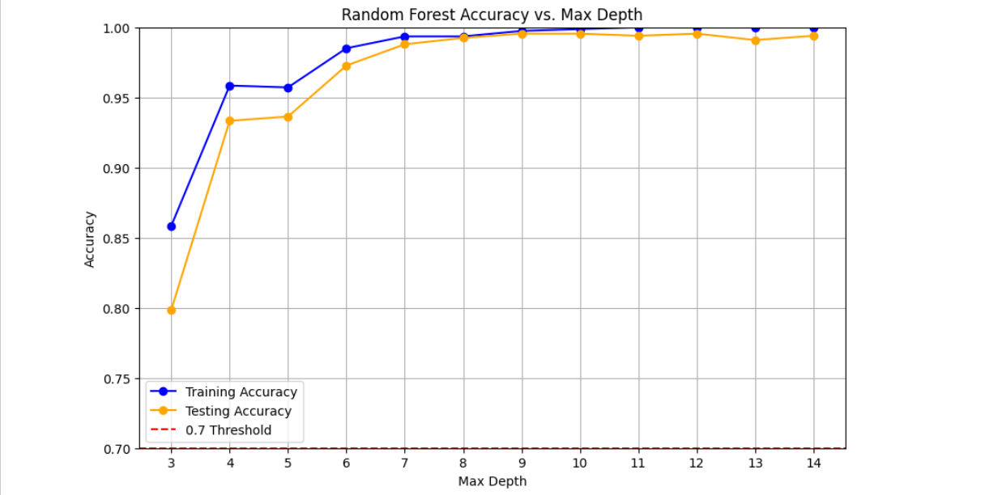

Figure ‑ Random Forest model training cycle summary Source:(Author Developed)

Based on the above chart, a maximum depth of 8 was selected for training the model. This depth was chosen to optimize performance while preventing overfitting or underfitting.

The model training resulted in the following accuracy metrics:

* Train Accuracy: 99.35%
* Test Accuracy: 99.24%

The selected depth ensured a balanced trade-off between model complexity and generalization, leading to stable and reliable predictions. This configuration allowed the model to achieve high accuracy while maintaining robustness across unseen data.

## Model Evaluation

To mitigate the risk of overfitting and enhance prediction accuracy, training was halted at an optimal point, with extensive fine-tuning applied to achieve the best model performance.

Both models delivered high accuracy during training, with the following results:

Model Performance Comparison

* Decision Tree Model
  + Train Accuracy: 95.39%
  + Test Accuracy: 95.00%
* Random Forest Model
  + Train Accuracy: 99.35%
  + Test Accuracy: 99.24%

Given the higher accuracy and robustness of the Random Forest model, it was selected for further robotic development to ensure optimal performance in real-world applications.

Final combined system is prediction is satisfied and provide satisfactory level recommendation as per input details.

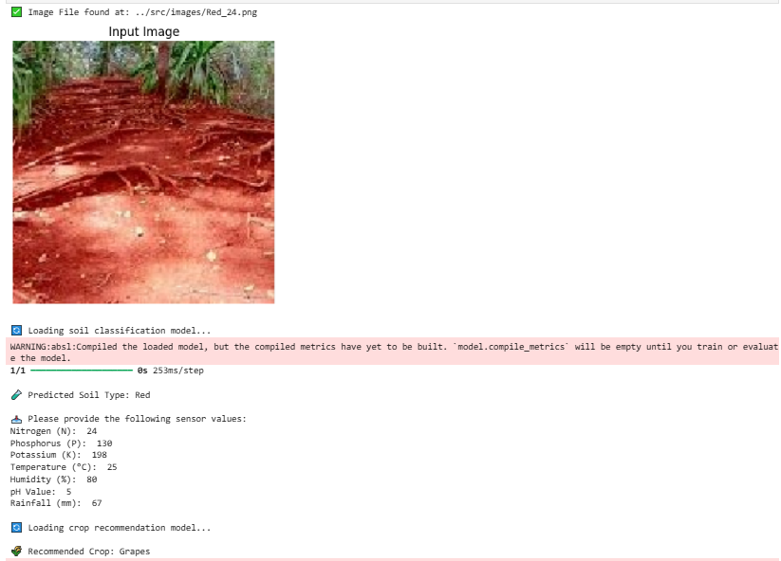

Figure ‑ Final system prediction Source: (Author Developed)

# Conclusion

This project successfully developed an ML model for Autonomous Reforestation Robot powered by machine learning to analyze environmental parameters and provide data-driven crop recommendations. By integrating sensor-based data collection with machine learning algorithms, the system effectively determines the most suitable crops for reforestation and agricultural applications, ensuring sustainable land management.

A multimodal data approach was employed, incorporating both image-based and tabular datasets to enhance prediction accuracy. Image processing was conducted using a Convolutional Neural Network (CNN) for soil type classification, while Decision Tree and Random Forest models were tested for crop recommendation based on environmental attributes.

After extensive evaluation, the Random Forest model was selected for its superior accuracy (Train Accuracy: 99.35%, Test Accuracy: 99.24%), outperforming the Decision Tree model. The selected model ensures optimal generalization and robust performance, making it suitable for real-world deployment in autonomous robotics applications.

The findings of this project demonstrate the potential of AI-driven robotics in precision agriculture, offering an efficient and scalable solution for environmental sustainability and reforestation efforts. Future enhancements could involve real-time adaptive learning, autonomous navigation, and integration with drone-based monitoring systems to further improve accuracy and operational efficiency.

# Future improvements.

While the current system demonstrates strong performance in crop recommendation and soil classification, further enhancements can improve its accuracy, efficiency, and adaptability to diverse environmental conditions. Below are some key areas for future improvement:

1. Expanding the Dataset
   1. To enhance model accuracy and robustness, a larger and more diverse image dataset should be incorporated, covering a wider variety of soil textures and conditions, particularly those found in desert regions.
   2. The tabular dataset should also be expanded to include detailed soil and climate attributes of desert areas, enabling the system to make better predictions in arid environments where reforestation is most challenging.
2. Advanced Machine Learning Techniques
   1. Implementing Deep Learning models such as Transformers or Hybrid CNN-RNN architectures could improve feature extraction and pattern recognition in complex terrains.
   2. Self-supervised learning and transfer learning can be integrated to adapt the model to new environmental conditions with minimal manual intervention.
3. Real-time Adaptive Learning
   1. The current model is pre-trained, meaning it does not learn from real-time data. Future versions should support continuous learning through online machine learning techniques, allowing the system to improve over time as new data is collected.
4. Integration with Remote Sensing & GIS Technologies
   1. Incorporating satellite imagery and drone-based data collection can provide a broader view of soil and vegetation conditions, helping the model make better-informed decisions.
   2. Geographic Information Systems (GIS) can be utilized to map soil health trends over time, improving the decision-making process for large-scale reforestation projects.
5. Autonomous Navigation and Deployment
   1. The robot can be further enhanced with autonomous navigation algorithms, allowing it to efficiently scan large desert areas without human intervention.
   2. Integrating LiDAR, GPS, and real-time sensor fusion would enable the system to move intelligently through rugged and remote environments, ensuring optimal seed placement in desert regions.
6. Integration with IoT and Cloud Computing
   1. Connecting the system to an IoT-based platform can enable real-time monitoring and remote control, allowing researchers and farmers to track soil conditions and model predictions remotely.
   2. Using cloud-based processing can allow the model to handle larger datasets and more complex computations, improving performance in large-scale deployments.
7. Energy Efficiency and Sustainability
   1. Future versions of the robot should incorporate solar power or energy-efficient components, enabling it to operate off-grid in remote desert areas for extended periods.

# Live Demonstration

Live demonstration can be watch via below link;

YouTube uploaded [video demonstration](https://youtu.be/1Edy1CHsnU4). (URL: https://youtu.be/1Edy1CHsnU4)

# References

Dharmaraj, 2022. *Convolutional Neural Networks (CNN) — Architecture Explained.* [Online]   
Available at: https://medium.com/@draj0718/convolutional-neural-networks-cnn-architectures-explained-716fb197b243  
[Accessed 25 03 2025].

IBM, 2024. *What is a decision tree?.* [Online]   
Available at: https://www.ibm.com/think/topics/decision-trees  
[Accessed 25 03 2025].